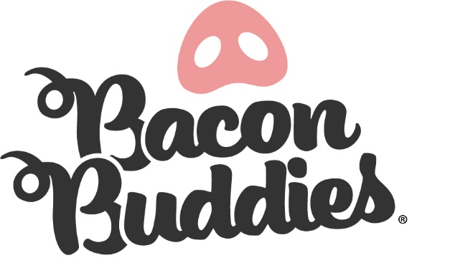
(County Name) County Bacon Buddies® Participant

Join us for the Bacon Buddies® Show at (County Name) County Fair!
WHO: Persons with an intellectual and/or developmental disability age of 10 years and older. Each participant will be paired with two youth mentors and a pig.
WHAT: Bacon Buddies® participants will have the opportunity to experience showing a pig. The judge will assess how the mentors, participant and pig work together as a cohesive unit. All participants will receive a ribbon, t-shirt, 2 admission tickets for entrance into the County Fair and 1 parking pass.

WHEN: Date and Time of the Bacon Buddies® Event
Arrival: 5:30 pm
Timeline: 5:45 pm Mentors, Pig and Participant Meet and Greet & Meal
6:50 pm Group Picture (All participants and mentors)
7:00 – 8:00 pm Bacon Buddies® Swine Show

WHERE: Location of Bacon Buddies® Event
SHOW ATTIRE: Closed toe shoes, long pants, and Bacon Buddies® T-shirt
REGISTRATION DEADLINE: (Date of Deadline)
PLEASE NOTE: There are a variety of activities, lights and sounds at (County Name) County and in the Swine Barn. Please bring any calming or auditory devices necessary to enhance this opportunity for your participant. Parents and/or guests are encouraged to watch the show from the bleachers but will not be allowed in the show ring during the Show.
QUESTIONS? Please email: (Contact Information)

Please see next pages for required consent and registration form for participants of this year’s Bacon Buddies® event. Parent/guardian is also required to complete liability waiver given.

(County Name) County Bacon Buddies® Registration Form
Participant Name: ___________________________________________________________________________________
Address: ___________________________________________________________________________________________
City/State/Zip:______________________________________________________________________________________
Email Address: ______________________________________Cell Phone: ____________________________________ __
T-Shirt (circle): Child Size S M L XL Adult Size S M L XL XXL
Gender (circle): Female Male Date of Birth (Month, Day, Year): ____/____/____
School: ___________________________________________________________________________________________
Hobbies/Interests: ___________________________________________________________________________________
__________________________________________________________________________________________________
__________________________________________________________________________________________________

Special Needs Information:
Nature of Disability: ________________________________________________________________________________
Does participant use a walker, wheelchair, or crutches? YES NO If YES, which one: __________
Seizures: Y/N Diabetes: Y/N Allergies: _______________________________

Parent/Legal Guardian Name(s): _______________________________________________________________________
Address (If different from Show person): _________________________________________________________________
Emergency Contact Name and Cell Number: ______________________________________________________________
Relationship to Show person: __________________________________________________________________________

Submit registration form and release to:
(County Name) County Fair
Address: (Information)
Email: (Information)

Please send in consent and registration form postmarked by (Date of Deadline)

(County Name) County Bacon Buddies® Parent/Guardian Liability Waiver
WAIVER TO BE COMPLETED BY PARENT OR GUARDIAN
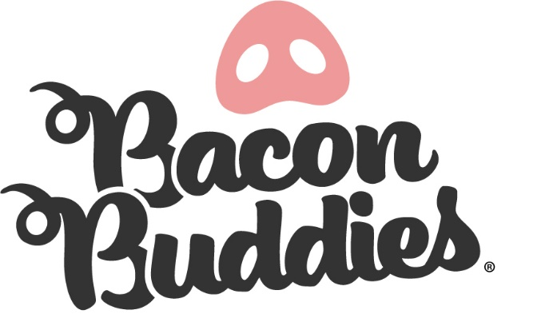
I am the parent/legal guardian of ___________________________________. (participant’s first and last name) I verify my child meets the participation requirements (10 years of age or older and has an intellectual and/or developmental disability) and has my permission to participate in the (County Name) County Bacon Buddies® show.
I understand the nature of the Bacon Buddies® show and believe my child is qualified, in good health, and is mentally and physically able to participate. I fully accept and assume all risks and responsibilities for losses, costs, and/or damages my child may incur because of his/her participation. If I, or the Bacon Buddies® show management, feel my child’s participation is unsafe at any time, I agree my child will discontinue participation immediately.
As an (County Name) County Fair exhibitor, I hereby acknowledge that my child’s photograph may be taken by the official (County Name) County Fair photographer for use by the (County Name) County Fair and agree to release and hold harmless the State of Iowa, (County Name) County Fair, their officers, employees and agents and any and all parties to whom this or any photograph may be released. This photograph was taken for artistic reasons or newsworthiness and I agree that it may be released to any medium and may be used in any manner for any purpose whatsoever without compensation.
I fully understand the animal project my child is working with is not my child’s animal and he/she is expected to care for the animal with the utmost respect.

It is understood and agreed that neither the State of Iowa nor the (County Name) County Fair shall be liable for damages. _______________________ (name of participant) does hereby release and hold harmless the State of Iowa, the (County Name)County Fair; the (County Name) County Fair Board; and their agents, officers and employees from any responsibility whatsoever resulting from or coming out of participation at the (County Name) County Fair by:

_______________________________________
PRINTED NAME OF PARENT/LEGAL GUARDIAN

____________________________________ __________________
SIGNATURE OF PARENT/LEGAL GUARDIAN DATE

